1. Analysis Overview

The primary focus of this project was to determine whether or not a song would be a hit, a flop, and why it ended up that way. The primary things to take from this analysis, if you were to only take a few would be:

* Name recognition tends to be the largest factor in a song’s popularity
* Genre tends to have a much larger impact than any one feature of a song
* Features such as danceability, loudness, energy, and valence do have an influence on the popularity of a song, but their impact is noticeably lower than the artist’s own popularity.
* If you want to gain popularity, targeting popular genres such as rap, rock, or hip hop is generally the best way to go.
* If you want to determine if a song will be a flop, you can view its features compared to other popular songs, as well as the popularity of the artist

1. Popularity

When looking at the popularity of a song there are a few things I found are very important to consider.

* Certain genres are much more popular than others
  + Examples are pop, rap, trap, and boy band
  + Other mainstream genres that aren’t as popular are country and classical
  + Country becomes much more popular when mixed with other genres like pop or rap
* Artists can be extremely popular with very few songs or have a large number of songs but be unpopular.
* Songs lose popularity over time. This means that songs released today have a solid chance of being somewhat popular when compared to the rest of the years.
  + Average popularity of all songs is 31 out of 100
  + Average popularity in the last 10 years is almost 60 out of 100
* Factors such as liveness, acousticness, loudness, etc. very little effect on the popularity of a song in the last 10 years
  + This means the popularity is based more on categorical features such as the artist or the genre.

1. What makes a song unpopular?

There’s no one formula for a flop, but there are some usual suspects. Low danceability, long duration, more liveness, too much speech, a tempo of <= 2 or >= 8, and loudness <= 2 or = 10. Genre also matters for music popularity. I have a list(too long to fit on page) that you can consult to approve future artists and their specialties. Examples of worse genres being country, classical, etc.

Lastly, by creating synthetic data that highlighted individual features, I was able to conclude that the simplest way to create a flop is to utilize only a single category to the neglect of others. In the figure below, I can see that when a single category is favored, the likelihood of popularity is consistently below 10% with the exception of duration.

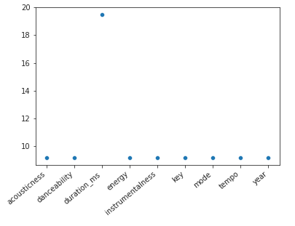

*The likelihood of popularity based on median values in a single category*

1. Conclusion

In conclusion I’ve determined the following:

It’s not how you flow, it’s who you know.

* How popular the musician is contributes heavily to how popular a song is.
* Songs in the pop, rap, trap, and boy band genres will generally be more popular.
* Country and classical aren’t as popular
* Don’t make a song that I can’t jam to, that’s really long, performed live, with too much talking, that’s really slow or really fast, and that’s really quiet or blows out your speakers.
* Ezra: I knew it! Computers can’t tell me how to make my art.